**Thruster Report**

|  |  |
| --- | --- |
| **Thruster Ratio:** | **1.200** |
| **Magnetic Field:** | **125 mT** |
| **Anode Power:** | **147 W** |
| **Anode Current:** | **2.0 A** |
| **Anode Energy:** | **6306.3 J** |
| **Propellant:** | **Argon 0.500 mg/s** |

**Thruster Details: Nagoya magnet, LaB6 cathode, 1 mm orifice, copper anode, 80 mm internal diameter. CoM correction method: Anode Energy, Pre-offset 0.0 s, Post-offset 100.0 s, Cold-Gas thrust 0.1 mN**

|  |  |  |  |  |  |  |
| --- | --- | --- | --- | --- | --- | --- |
| Thrust | Thrust Eff. | ISP | Total DOF | Coverage Factor | Exp. Uncertainty | Std. Uncertainty |
| 2.4 mN | 3.9 % | 487.7 sec | 45 | 2.06 | 3.2 mN | 1.6 mN |

**Thrust-Stand Uncertainty Components**

|  |  |  |  |  |  |  |  |
| --- | --- | --- | --- | --- | --- | --- | --- |
|  | Weights | Scale | Hysteresis | Repeatability | Noise | Offset | Drift |
| Value | 0.0 mN | 0.8 mN | 0.4 mN | 0.4 mN | 1.1 mN | 0.4 mN | 0.3 mN |
| DOF | 30 | 6 | 6 | 6 | 31 | 4 | 4 |

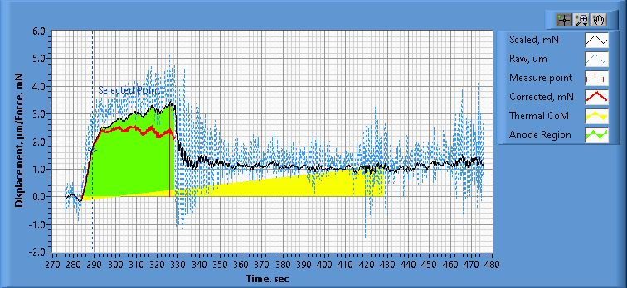

**Figure 1. Thrust Plot**

File Name: Philtech Data 2025.04.17_19.39.58.csv

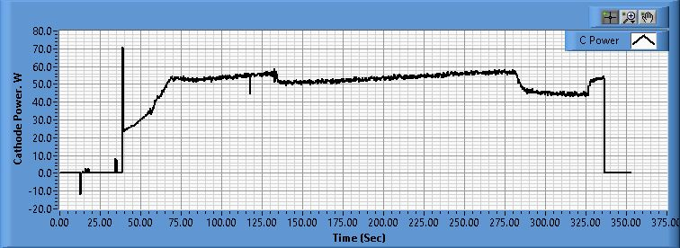

**Figure 2. Cathode Power Plot**

File Name: PSU C Data 2025.04.17_19.40.00.csv

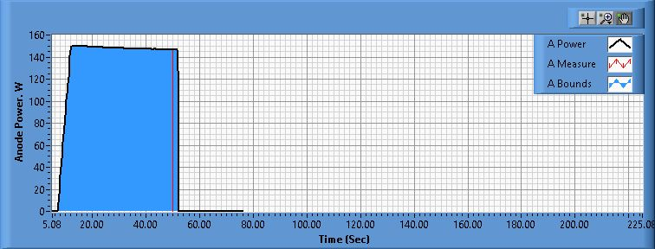

**Figure 3. Anode Power Plot**

File Name: PSU A Data 2025.04.17_19.44.34.csv

**Pre-Cal. Information**

File Name: Philtech Data 2025.04.16_23.55.41.csv

Start/Stop times (24 h): 23:55:49 23:59:35

Sensitivity: 1.47 um/mN

|  |  |  |  |
| --- | --- | --- | --- |
| Offset | Drift | Scale Factor | Scale Std.Dev |
| 0.027 mN | 0.001 mN/s | 0.682 | 1.426 mN |

Plateau values:

|  |  |  |  |  |  |  |  |  |  |  |
| --- | --- | --- | --- | --- | --- | --- | --- | --- | --- | --- |
| Weight 0 | Weight 1 | Weight 2 | Weight 3 | Weight 4 | Weight 5 | Weight 4 | Weight 3 | Weight 2 | Weight 1 | Weight 0 |
| -0.1 mN | 22.2 mN | 38.5 mN | 59.7 mN | 80.2 mN | 101.0 mN | 79.1 mN | 59.1 mN | 38.1 mN | 21.9 mN | 0.0 mN |

**Post-Cal. Information**

File Name: Philtech Data 2025.04.17_19.39.58.csv

Start/Stop times (24 h): 19:48:42 19:52:40

Sensitivity: 1.38 um/mN

|  |  |  |  |
| --- | --- | --- | --- |
| Offset | Drift | Scale Factor | Scale Std.Dev |
| -2.626 mN | -0.008 mN/s | 0.725 | 0.943 mN |

Plateau values:

|  |  |  |  |  |  |  |  |  |  |  |
| --- | --- | --- | --- | --- | --- | --- | --- | --- | --- | --- |
| Weight 0 | Weight 1 | Weight 2 | Weight 3 | Weight 4 | Weight 5 | Weight 4 | Weight 3 | Weight 2 | Weight 1 | Weight 0 |
| -0.6 mN | 19.2 mN | 37.5 mN | 58.2 mN | 79.3 mN | 100.2 mN | 78.8 mN | 58.6 mN | 37.0 mN | 19.4 mN | -0.9 mN |